**IOT BASED SMART PROTECTION SYSTEM**

**TEAM ID :** PNT2022TMID48513

**TEAM MEMBERS:**

Rasika.M

Nandhini.K

Parkavi.P.K

Chitra.J

Poovizhi.S

**PROJECT REPORT**

**1**. **INTRODUCTION:**

**1.1PROJECT OBJECTIVE:**

This project is based on Internet Of Things (IoT),and the main objective of this project is to address the problem of crop vandalization by wild animals.This project is to provide an effective solution to this problem ,so that the economic losses incurred by our farmers are minimized and they have a good crop yield.

**1.2 PURPOSE**:

Our main purpose of the project is to develop intruder alert to the farm, to avoid losses due to animal and fire. These intruder alert protect the crop that damaging that indirectly increase yield of the crop. The develop system will not harmful and injurious to animal as well as human beings. Theme of project is to design a intelligent security system for farm protecting by using embedded system have a good crop yield.

**2. LITERATURE SURVEY:**

**2.1 EXISTING PROBLEM:**

The existing system mainly provide the surveillance functionality. Also these system don’t provide protection from wild animals, especially in such an application area. They also need to take actions based on the type of animal that tries to enter the area, as different methods are adopted to prevent different animals from entering restricted areas. The other commonly used method by farmer in order to prevent the crop vandalization by animals include building physical barriers, use of electric fences and manual surveillance and various such exhaustive and dangerous method.

**REFERENCES:**

i[1] ArturFrankiewicz; RafałCupek.” Smart Passive Infrared Sensor - Hardware Plat-

form “Year: 2013 IECON 2013 - 39th Annual Conference of the IEEE Industrial

Electronics Society Pages: 7543 – 7547

[2] Discant, A. Rogozan, C. Rusu and A. Bensrhair, “Sensors for Obstacle Detection”

2007 30th International Spring Seminar on Electronics Technology (ISSE),

Cluj-Napoca, 2007, pp. 100-105. doi: 10.1109/ISSE.2007.4432828 Volume:01

Pages:859-862, DOI:10.1109/ICCSNT.2015.7490876, IEEE Conference Publications.

**PROBLEM STATEMENT :**

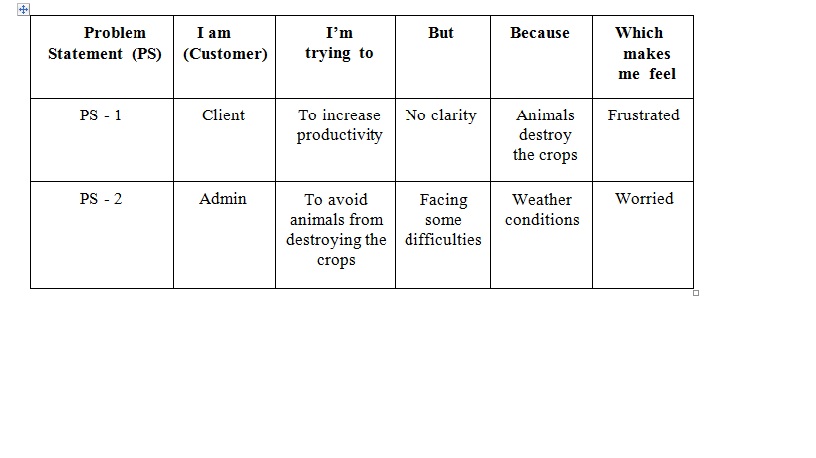 **IDEATION AND PROPOSED SOLUTION**

**EMPATHY MAP CANVAS:**

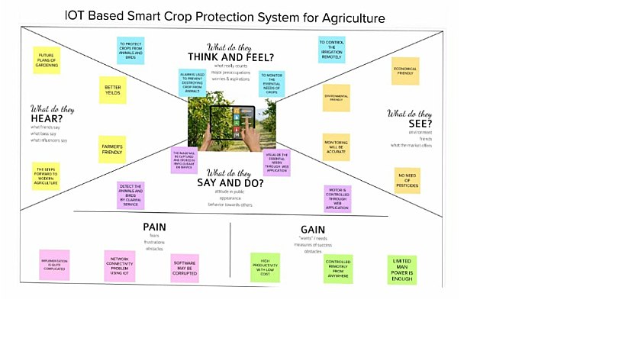

**IDEATION AND BRAINSTORMING:**

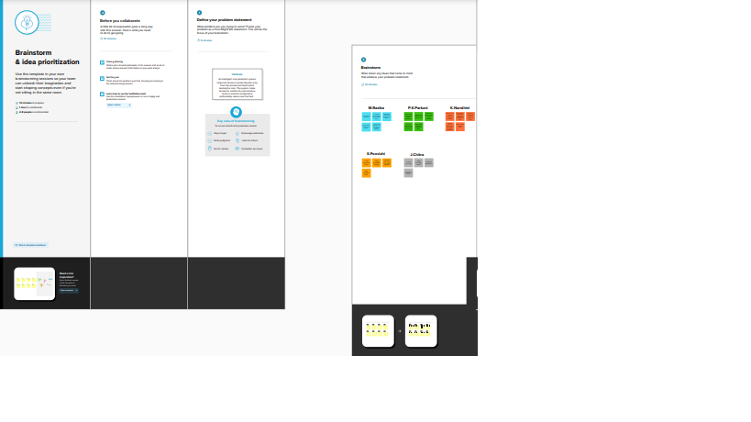

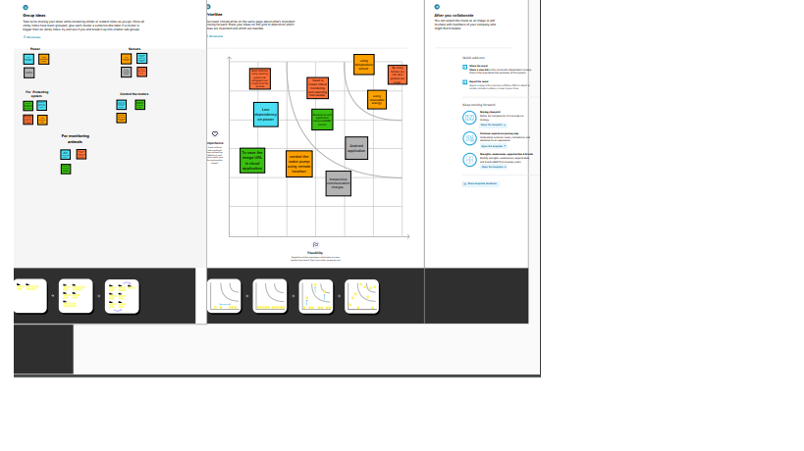

**PROPOSED SOLUTION:**

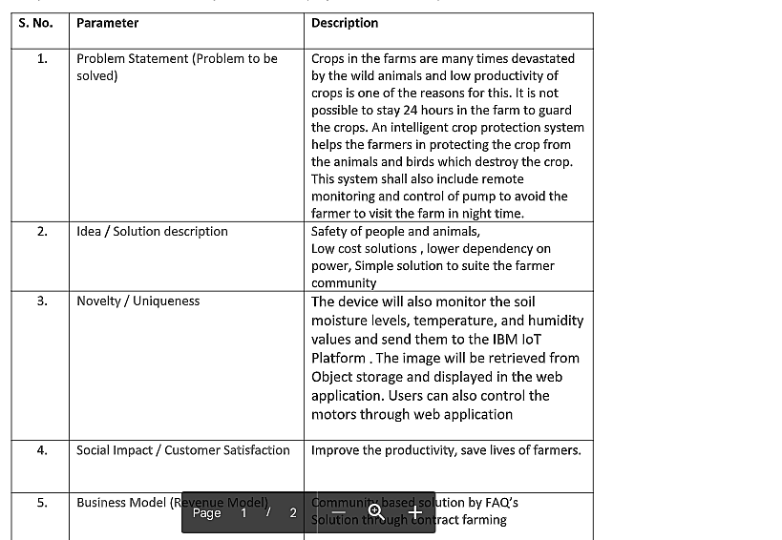

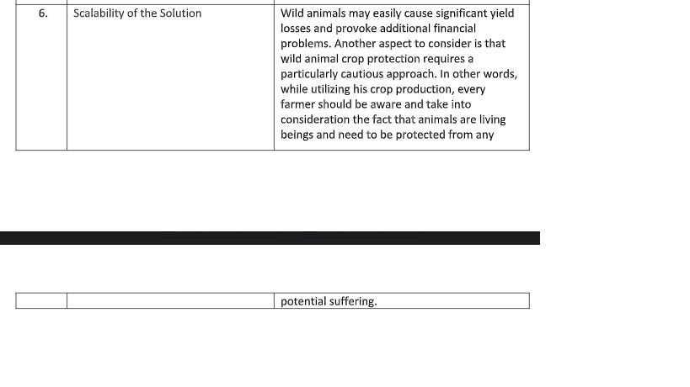

**PROBLEM SOLUTION FIT:**

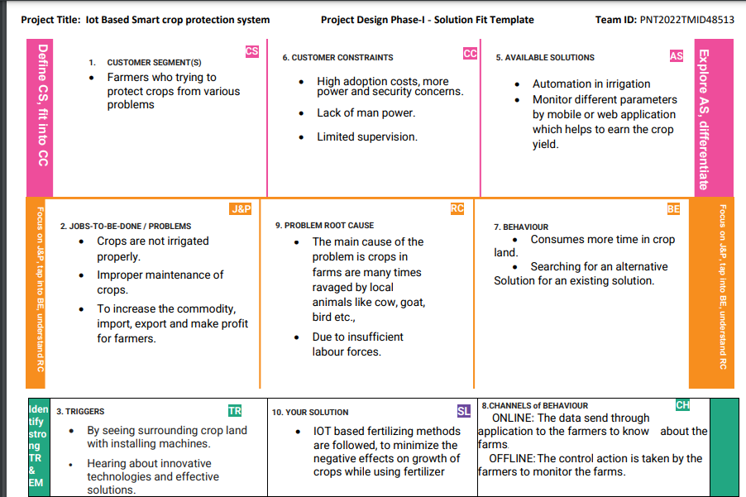

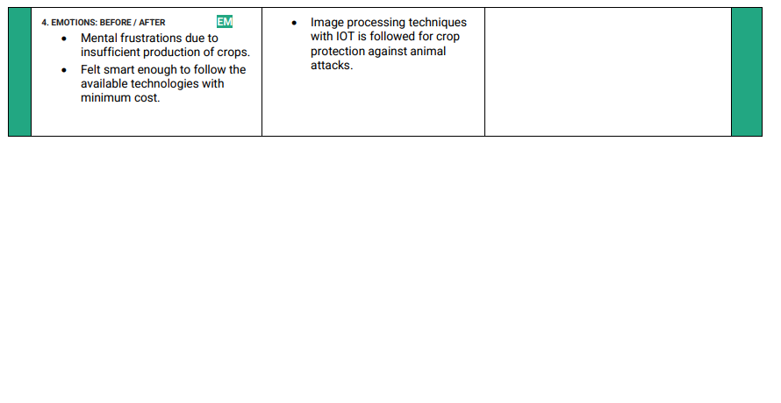

**REQUIREMENT ANALYSIS**

**FUNCTIONAL REQUIREMENT:**

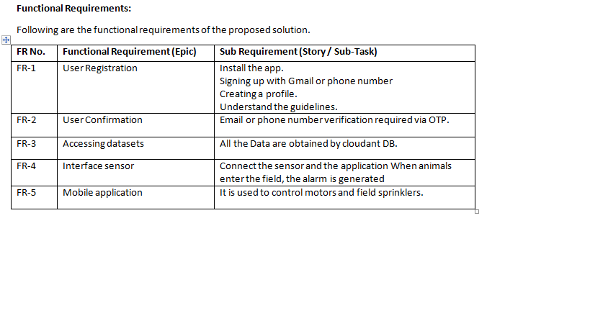

**NON FUNCTINAL REQUIREMENT:**

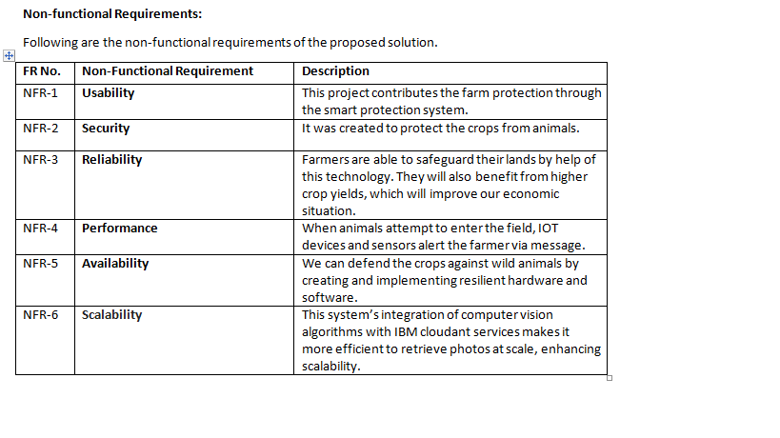

**PROJECT DESIGN**

**DATA FLOW DIAGRAM:**

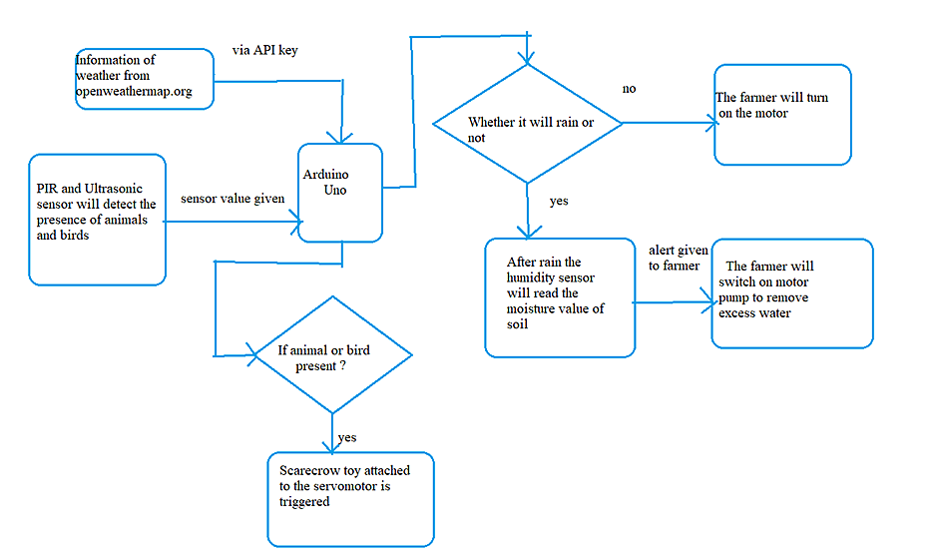

**SOLUTION AND TECHNICAL ARCHITECTURE**

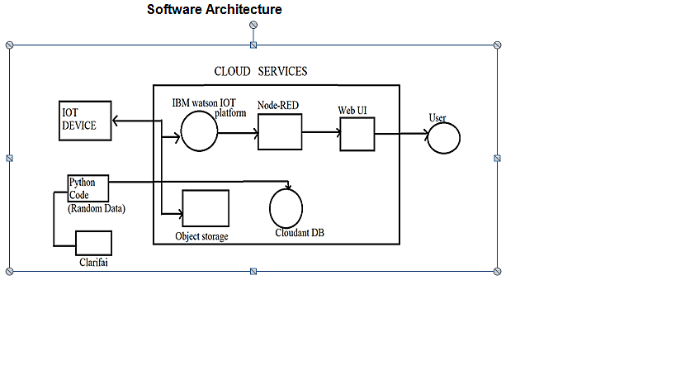

**HARDWARE ARCHITECTURE**

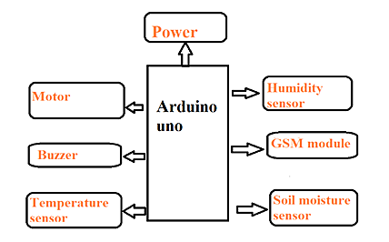

**USER STORIES:**

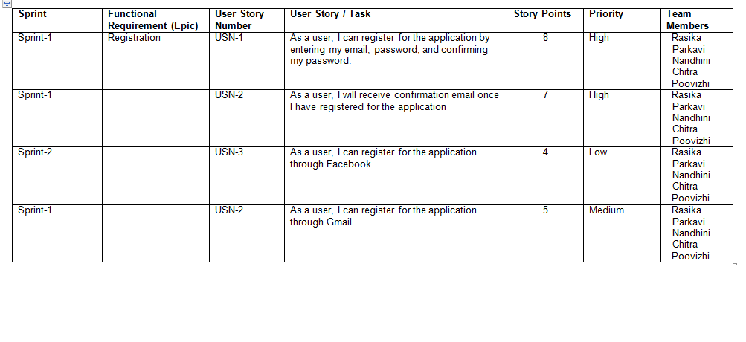

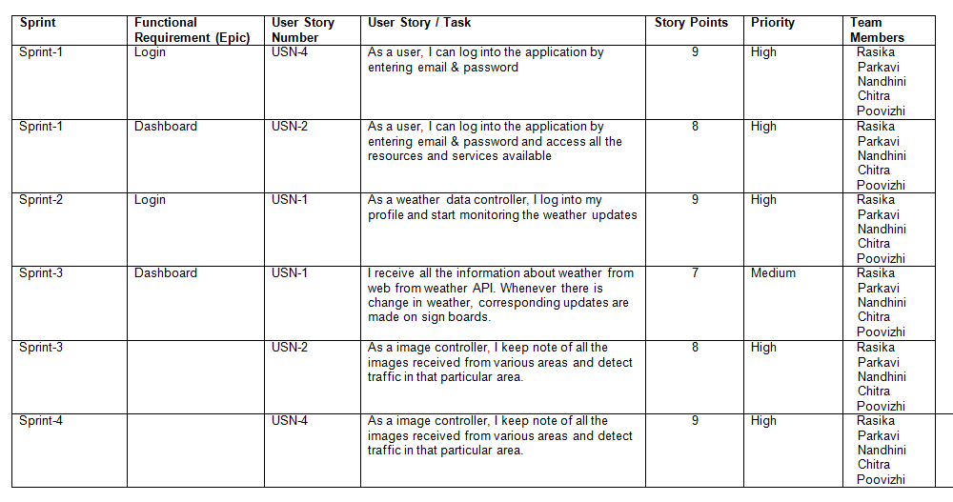

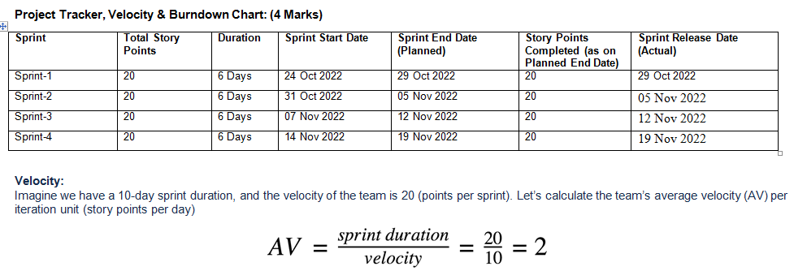

**CODING AND SOLUTIONING**

**FEATURE-1**

import random

import ibmiotf.application

import ibmiotf.device

from time import sleep

import sys

#IBMWatson Device Credentials.

organization = "op701j"

deviceType = "Rasika"

deviceId = "Rasikaid"

authMethod = "token"

authToken = "1223334444"

def myCommandCallback(cmd):

print("Command received: %s" % cmd.data['command'])

status=cmd.data['command']

if status=="sprinkler_on":

print ("sprinkler is ON")

else :

print ("sprinkler is OFF")

#print(cmd)

try:

deviceOptions = {"org": organization, "type": deviceType, "id": deviceId, "auth-method": authMethod, "auth-token": authToken}

deviceCli = ibmiotf.device.Client(deviceOptions)

except Exception as e:

print("Caught exception connecting device: %s" % str(e))

sys.exit()

#Connecting to IBM watson.

deviceCli.connect()

while True:

#Getting valuesfrom sensors.

temp_sensor = round( random.uniform(0,80),2)

PH_sensor = round(random.uniform(1,14),3)

camera = ["Detected","Not Detected","Not Detected","Not Detected","Not Detected","Not Detected",]

camera_reading = random.choice(camera)

flame = ["Detected","Not Detected","Not Detected","Not Detected","Not Detected","Not Detected",] flame_reading = random.choice(flame)

moist_level = round(random.uniform(0,100),2)

water_level = round(random.uniform(0,30),2)

#storing the sensor data to send in json format to cloud.

temp_data = { 'Temperature' : temp_sensor }

PH_data = { 'PH Level' : PH_sensor }

camera_data = { 'Animal attack' : camera_reading}

flame_data = { 'Flame' : flame_reading }

moist_data = { 'Moisture Level' : moist_level}

water_data = { 'Water Level' : water_level}

# publishing Sensor data to IBM Watson for every 5-10 seconds.

success = deviceCli.publishEvent("Temperature sensor", "json", temp_data, qos=0)

sleep(1)

ifsuccess:

print(" ............................publish ok ............................. ")

print("Published Temperature = %s C" % temp_sensor, "to IBM Watson")

success = deviceCli.publishEvent("PH sensor", "json", PH_data, qos=0)

sleep(1)

ifsuccess:

print ("Published PH Level = %s" % PH_sensor, "to IBM Watson")

success = deviceCli.publishEvent("camera", "json", camera_data, qos=0)

sleep(1)

ifsuccess:

print ("Published Animal attack %s " % camera_reading, "to IBM Watson")

success = deviceCli.publishEvent("Flame sensor", "json", flame_data, qos=0)

sleep(1)

ifsuccess:

print ("Published Flame %s " % flame_reading, "to IBM Watson")

success = deviceCli.publishEvent("Moisture sensor", "json", moist_data, qos=0)

sleep(1)

ifsuccess:

print ("Published Moisture Level = %s " % moist_level, "to IBM Watson")

success = deviceCli.publishEvent("Water sensor", "json", water_data, qos=0)

sleep(1)

ifsuccess:

print ("Published Water Level = %s cm" % water_level, "to IBM Watson")

print ("")

#Automation to controlsprinklers by present temperature an to send alert message to IBM Watson.

if (temp_sensor > 35):

print("sprinkler-1 is ON")

success = deviceCli.publishEvent("Alert1", "json",{ 'alert1' : "Temperature(%s) is high,sprinkerlers are turned ON" %temp_sensor } ,qos=0)

sleep(1)

ifsuccess:

print( 'Published alert1 : ', "Temperature(%s) is high,sprinkerlers are turned ON" %temp_sensor,"to IBM Watson")

print("")

else:

print("sprinkler-1 is OFF")

print("")

#To send alert message if farmer usesthe unsafe fertilizer to crops.

if (PH_sensor > 7.5 or PH_sensor < 5.5):

success = deviceCli.publishEvent("Alert2", "json",{ 'alert2' : "Fertilizer PH level(%s) is notsafe,use other fertilizer" %PH_sensor } , qos=0)

sleep(1)

ifsuccess:

print('Published alert2 : ' , "Fertilizer PH level(%s) is notsafe,use other fertilizer" %PH_sensor,"to IBM Watson")

print("")

#To send alert message to farmerthat animal attack on crops.

if (camera_reading == "Detected"):

success = deviceCli.publishEvent("Alert3", "json", { 'alert3' : "Animal attack on crops detected" }, qos=0)

sleep(1)

ifsuccess:

print('Published alert3 : ' , "Animal attack on crops detected","to IBM Watson","to IBM Watson") print("")

#To send alert message if flame detected on crop land and turn ON the splinkersto take immediate action.

if(flame_reading == "Detected"):

print("sprinkler-2 is ON")

success = deviceCli.publishEvent("Alert4", "json", { 'alert4' : "Flame is detected crops are in danger,sprinklersturned ON" }, qos=0)

sleep(1)

ifsuccess:

print( 'Published alert4 : ' , "Flame is detected crops are in danger,sprinklers turned ON","to IBM Watson")

#To send alert message if Moisture level is LOW and to Turn ON Motor-1 forirrigation.

if (moist_level < 20):

print("Motor-1 is ON")

success = deviceCli.publishEvent("Alert5", "json", { 'alert5' : "Moisture level(%s) islow, Irrigation started" %moist_level }, qos=0)

sleep(1)

ifsuccess:

print('Published alert5 : ' , "Moisture level(%s) islow, Irrigation started" %moist_level,"to IBM Watson" )

print("")

#To send alert message if Waterlevel is HIGH and to Turn ON Motor-2 to take water out.

if (water_level > 20):

print("Motor-2 is ON")

success = deviceCli.publishEvent("Alert6", "json", { 'alert6' : "Water level(%s) is high,so motor is ON to take water out " %water_level }, qos=0)

sleep(1)

Ifsuccess:

print('Published alert6 : ' , "water level(%s) is high, so motor is ON to take water out " %water_level,"to IBM Watson" )

print("")

#command recived by farmer

deviceCli.commandCallback = myCommandCallback

# Disconnect the device and application from the cloud

deviceCli.disconnect()

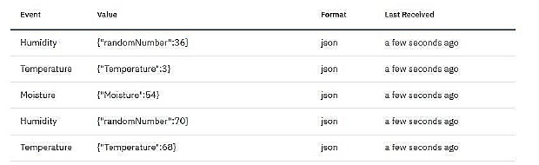

**FEATURES:**

Output: Digital pulse high (3V) when triggered (motion detected) digital low when idle (no motion detected). Pulse lengths are determined by resistors and capacitors on the PCB and differ from sensor to sensor. Power supply: 5V-12V input voltage for most modules (they have a 3.3V regulator),but 5V is ideal in case the regulator has different specs.

**BUZZER:**

**Specifications**

● RatedVoltage : 6V DC

● Operating Voltage : 4 to 8V DC

● Rated Current*: ≤30mA

● SoundOutput at 10cm* : ≥85dB

● Resonant Frequency : 2300 ±300Hz

● Tone: Continuous A buzzer is a loud noise maker.

Most modern ones are civil defense or air- raid sirens, tornado sirens, or the sirens on emergency service vehiclessuch as ambulances, police cars and fire trucks. There are two general types, pneumatic and electronic.

**FEATURE-2:**

i. Goodsensitivity to Combustible gas in wide range .

ii. Highsensitivity to LPG, Propane and Hydrogen .

iii. Longlife and low cost.

iv. Simpledrive circuit.

**User Acceptance Testing:**

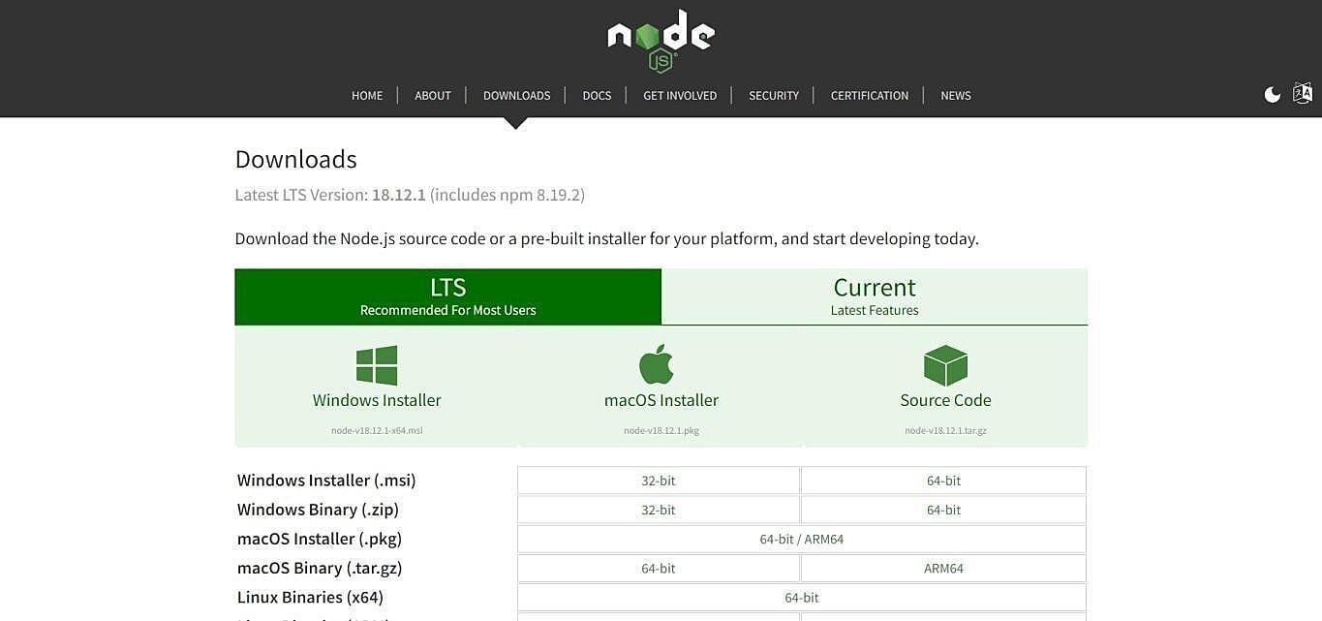

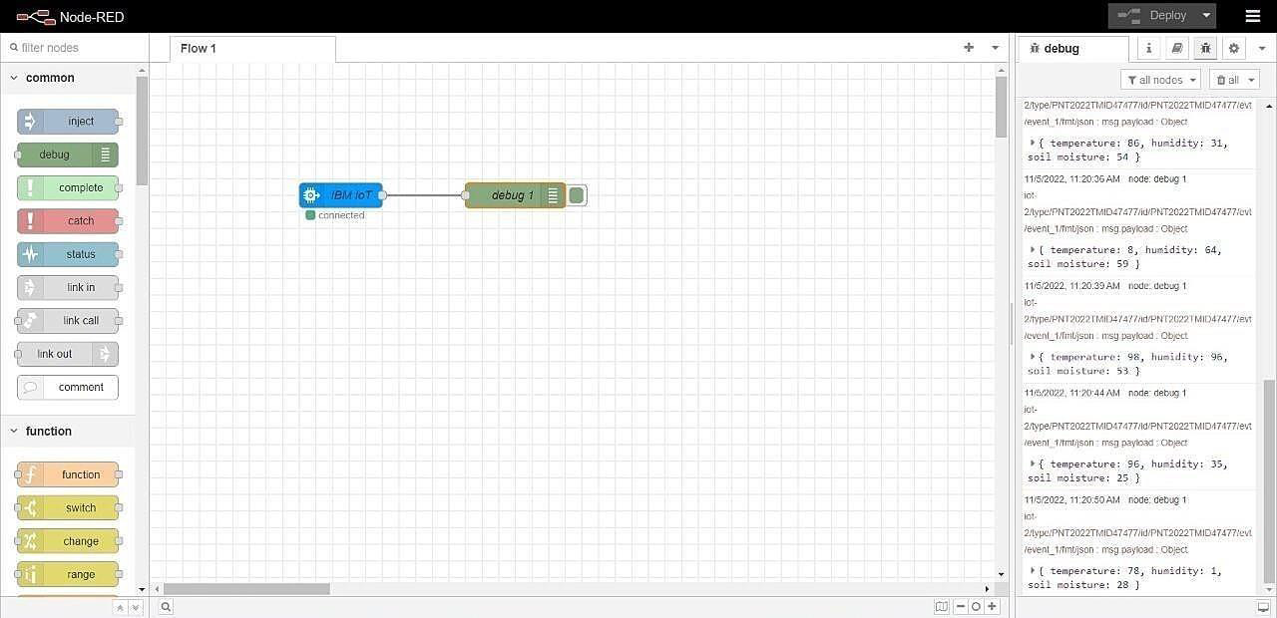

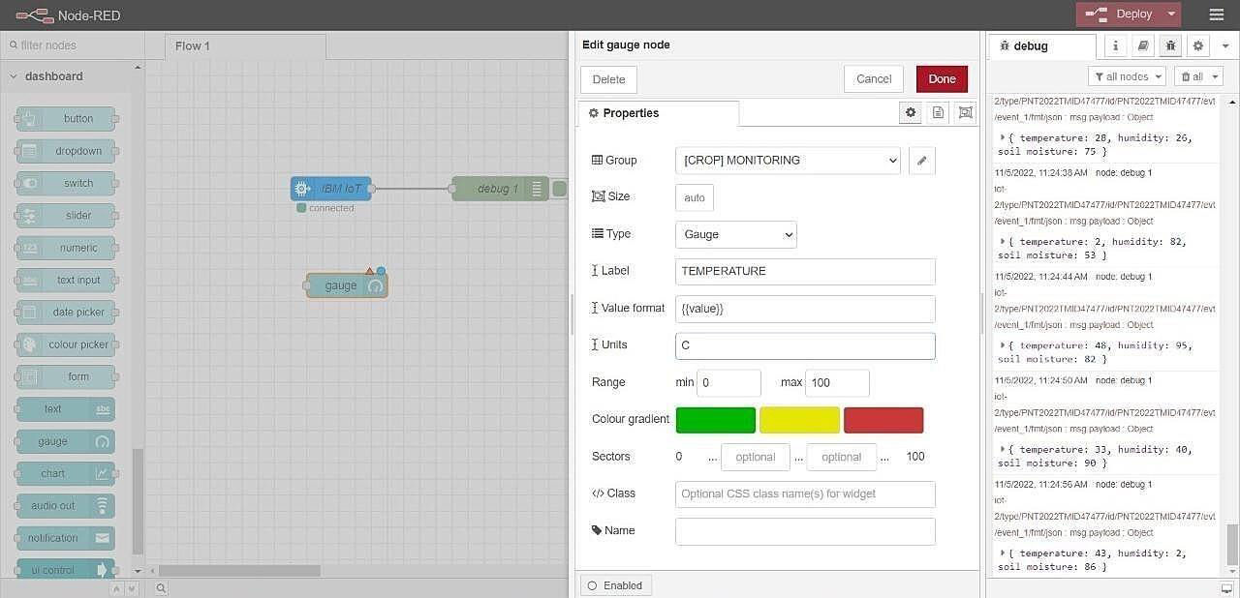

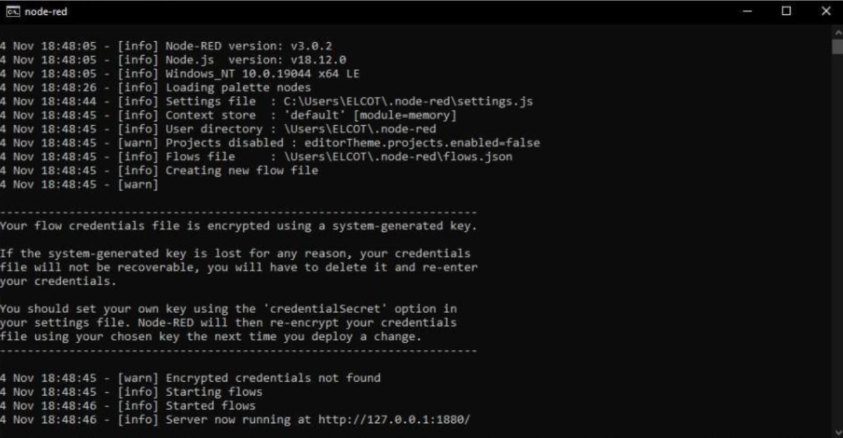

**RESULTS:**

The problem of crop vandalization by wild animals and fire has become a major social problem in current time.It requires urgent attention as no effective solution exists till date for this problem. Thus this project carries a great social relevance as it aims to address this problem. This project willhelp farmers in protecting their orchards and fields and save them from significant financial losses and will save them from the unproductive them in achieving better crop yields thus leading to their economic wellbeing.

**ADVANTAGES AND DISADVANTAGES :**

**Advantage:**

Controllable food supply. you might have droughts or floods, but if you are growing the crops and breeding them to be hardier, you have a better chanceof not straving. It allows farmers to maximize yields using minimum resources such as water,fertilizers.

**Disadvantage:**

The main disadvantage is the time it can take to process the information.in order to keep feeding people as the population grows you have to radically change theenvironment of the planet.

**CONCLUSION**

A IoT Web Application is built for smart agricultural system using Watson IoT platform, Watson simulator, IBM cloud and Node-RED.

**FUTURE SCOPE**

In the future, there will be very large scope, this project can be made based on Image processing in which wild animaland fire can be detected by cameras and if it comes towards farmthen system will be directly activated through wireless networks. Wild animals can also be detected by using wireless networks such as laser wireless sensors and by sensing this laser or sensor’s security system will beactivated.

**APPENDIX**

**SOURCE CODE**

import time importsys import ibmiotf.application # toinstallpip install ibmiotf importibmiotf.device

# Provide your IBM Watson Device Credentials organization = "8gyz7t" #

replace the ORG ID deviceType = "weather_monitor" #replace the Device

type deviceId = "b827ebd607b5" # replace Device ID authMethod = "token"

authToken = "LWVpQPaVQ166HWN48f" # Replace the authtoken

def myCommandCallback(cmd): # function for Callbackif

cm.data['command'] == 'motoron':

print("MOTOR ON IS RECEIVED")

elif cmd.data['command'] == 'motoroff':print("MOTOR OFF IS RECEIVED")

if cmd.command == "setInterval":

else:

if 'interval' not in cmd.data:

print("Error - command is missing requiredinformation: 'interval'")

interval = cmd.data['interval']

elif cmdprint("Error - command is missing requiredinformation: 'interval'")

interval = cmd.data['interval'] elif cmd.command == "print":

if 'message' not in cmd.data:

print("Error - commandis missing requiredinformation: 'message'") else:output = cmd.data['message']

print(output)

try:

deviceOptions = {"org": organization, "type": deviceType, "id": deviceId,"authmethod": authMethod,

"auth-token": authToken} deviceCli

= ibmiotf.device.Client(deviceOptions)#

..............................................

exceptException as e:

print("Caught exception connecting device: %s" % str(e))sys.exit()

# Connect and send a datapoint "hello" with value "world" into the cloud as an event oftype "greeting" 10 times

deviceCli.connect()

while True:

deviceCli.commandCallback = myCommandCallback

# Disconnect the device and application from the cloud deviceCli.disconnect()

**SENSOR.PY**

import time import

sysimport

ibmiotf.application

importibmiotf.device

import random

# Provide your IBM Watson Device Credentials organization = "8gyz7t" # replace the ORG ID deviceType = "weather_monitor" #replace the Device type deviceId = "b827ebd607b5" # replace Device ID authMethod = "token" authToken = "LWVpQPaVQ166HWN48f" # Replace the authtoken

def myCommandCallback(cmd):

print("Command received: %s" % cmd.data['command'])

print(cmd)

try:

deviceOptions = {"org": organization, "type": deviceType, "id": deviceId,

"auth-method": authMethod, "auth-token": authToken}

deviceCli = ibmiotf.device.Client(deviceOptions)

#..............................................

exceptException as e:

print("Caught exception connecting device: %s" % str(e))sys.exit()

# Connect and send a datapoint "hello" with value "world" into the cloud as an event oftype "greeting" 10 times

deviceCli.connect()

while True:

temp=random.randint(0,1

00)

pulse=random.randint(0,100)

soil=random.randint(0,100)

data = { 'temp' : temp, 'pulse': pulse ,'soil':soil}

#print data def

myOnPublishCallback():

print ("Published Temperature = %s C" % temp, "Humidity = %s %%" %pulse,"Soil Moisture = %s %%" % soil,"to IBM Watson")

success = deviceCli.publishEvent("IoTSensor", "json", data, qos=0, on_publish=myOnPublishCallback)

if not success: print("Not connected to

IoTF")

time.sleep(1)

deviceCli.commandCallback = myCommandCallback

# Disconnect the device and application from the cloud deviceCli.disconnect()

**Node-RED FLOW :**

[

{

"id":"625574ead9839b34 ",

"type":"ibmiotout", "z":"630c8601c5ac3295",

"authentication":"apiKey", "apiKey":"ef745d48e395ccc0", "outputType":"cmd", "deviceId":"b827ebd607b5",

"deviceType":"weather_monitor", "eventCommandType":"data", "format":"json",

"data":"data", "qos":0, "name":"IBM IoT", "service":"registere d","x":680, "y":220,

"wires":[]

},

{

"id":"4cff18c3274cccc4","type":"ui_button", "z":"630c8601c5ac3295",

"name":"",

"group":"716e956.00eed6c", "order":2,

"width":"0",

"height":"0",

"passthru":false, "label":"MotorON",

"tooltip":"",

"color":"",

"bgcolor":"",

"className":"",

"icon":"", "payload":"{\"command\":\"motoron\"}", "payloadType":"str",

"topic":"motoron",

"topicType":"s tr","x":360,

"y":160, "wires":[["625574ead9839b34"]]},

{

"id":"659589baceb4e0b0", "type":"ui_button", "z":"630c8601c5ac3295", "name":"",

"group":"716e956.00eed6c", "order":3,

"width":"0",

"height":"0", "passthru":true, "label":"MotorOF F",

"tooltip":"",

"color":"",

"bgcolor":"",

"className":"",

"icon":"", "payload":"{\"command\":\"motoroff\"}", "payloadType":"str",

"topic":"motoroff",

"topicType":"s tr","x":350,

"y":220, "wires":[["625574ead9839b34"]]},

{"id":"ef745d48e395ccc0","type":"ibmiot", "name":"weather_monitor","keepalive":"60", "serverName":"",

"cleansession":true, "appId":"",

"shared":false},

{"id":"716e956.00eed6c",

"type":"ui_group",

"name":"Form", "tab":"7e62365e.b7e6b8 ","order":1,

"disp":true,

"width":"6", "collapse":fal se},

{"id":"7e62365e.b7e6b8",

"type":"ui_tab",

"name":"contorl", "icon":"dashboard ","order":1,

"disabled":false,

"hidden":false}

]

[

{

"id":"b42b5519fee73ee2", "type":"ibmiotin", "z":"03acb6ae05a0c712", "authentication":"apiKey", "apiKey":"ef745d48e395ccc0",

"inputType":"evt", "logicalInterface":"", "ruleId":"", "deviceId":"b827ebd607b5", "applicationId":"",

"deviceType":"weather_monitor",

"eventType":"+",

"commandType":"",

"format":"json",

"name":"IBMIoT", "service":"registered", "allDevices":"", "allApplications":"", "allDeviceTypes":"", "allLogicalInterfaces":"", "allEvents":true, "allCommands":"", "allFormats

":"",

"qos":0,

"x":270,

"y":180,

"wires":[["50b13e02170d73fc","d7da6c2f5302ffaf","a949797028158f3f","a71f164bc3 78bcf1"]]

},

{

"id":"50b13e02170d73fc ",

"type":"function",

"z":"03acb6ae05a0c712 ","name":"Soil Moisture",

"func":"msg.payload = msg.payload.soil;\nglobal.set('s',msg.payload);\nreturn msg;", "outputs":1,

"noerr":

0,

"initialize ":"",

"finalize":"",

"libs":[],

"x":490,

"y":120,

"wires":[["a949797028158f3f","ba98e701f55f04fe"]]

},

{

"id":"d7da6c2f5302ffaf","type":"function", "z":"03acb6ae05a0c712", "name":"Humidity",

"func":"msg.payload = msg.payload.pulse;\nglobal.set('p',msg.payload)\nreturn msg;",

"outputs":1,

"noerr":

0,

"initialize ":"",

"finalize":"",

"li bs ":[

],

"x ":

48

0,

"y":260, "wires":[["a949797028158f3f","70a5b076eeb80b70"]]

},

{ "id":"a949797028158f3f ",

"type":"debug",

"z":"03acb6ae05a0c712 ","name":"IBMo/p", "active":true, "tosidebar":true, "console":false, "tostatus":false, "complete":"payload", "targetType":"msg",

"statusVal":"",

"statusType":"auto", "x":780,

"y":180,

"wires":[]

},

{

"id":"70a5b076eeb80b70", "type":"ui_gauge", "z":"03acb6ae05a0c712", "name":"", "group":"f4cb8513b95c98a4", "order":6,

"width":"0",

"height":"0",

"gtype":"gage",

"title":"Humidity",

"label":"Percentage(%)",

"format":"{{value}}

","min":0,

"max":"100", "colors":["#00b500","#e6e600","#ca3838"], "seg1":"", "seg2":"",

"className ":"","x":86 0,

"y":260,

"wires":[]

},

{

"id":"a71f164bc378bcf1","type":"function", "z":"03acb6ae05a0c712", "name":"Temperature",

"func":"msg.payload=msg.payload.temp;\nglobal.set('t',msg.payload);\nreturn msg;","outputs":1, "noerr":

0,

"initialize ":"",

"finalize":"",

"li bs ":[

],

"x ":

49

0, "y":360,

"wires":[["8e8b63b110c5ec2d","a949797028158f3f"]]

},

{

"id":"8e8b63b110c5ec2d", "type":"ui_gauge", "z":"03acb6ae05a0c712", "name":"", "group":"f4cb8513b95c98a4", "order":11,

"width":"0",

"height":"0",

"gtype":"gage", "title":"Temperature", "label":"DegreeCelcius", "format":"{{value}}", "min":0,

"max":"100", "colors":["#00b500","#e6e600","#ca3838"],"seg1":"", "seg2":"",

"className ":"",

"x":790,

"y":360,

"wires":[]

},

{

"id":"ba98e701f55f04fe", "type":"ui_gauge", "z":"03acb6ae05a0c712", "name":"", "group":"f4cb8513b95c98a4", "order":1,

"width":"0",

"height":"0",

"gtype":"gage",

"title":"Soil Moisture", "label":"Percentage(%)",

"format":"{{value}}

","min":0,

"max":"100", "colors":["#00b500","#e6e600","#ca3838"],"seg1":"", "seg2":"",

"className ":"",

"x":790,

"y":120,

"wires":[]

},

{

"id":"a259673baf5f0f98 ","type":"httpin", "z":"03acb6ae05a0c712 ","name":"",

"url":"/sensor",

"method":"ge t", "upload":fals e, "swaggerDoc"

:"","x":370, "y":500,

"wires":[["18a8cdbf7943d27a"]]

},

{

"id":"18a8cdbf7943d27a","type":"function", "z":"03acb6ae05a0c712", "name":"httpfunction",

"func":"msg.payload{\"pulse\":global.get('p'),\"temp\":global.get('t'),\"soil\":global.get( 's')};\nreturn

msg;",

"outputs":1,

"noerr":0,

"initialize":"",

"finalize":"", "li

bs

":[

],

"x ":

63

0,

"y":500, "wires":[["5c7996d53a445412"]]

},

{ "id":"5c7996d53a445412 ",

"type":"httpresponse",

"z":"03acb6ae05a0c712 ","name":"",

"statusCode":"",

"header s":{},

"x":870,

"y":500,

"wires":[]

},

{

"id":"ef745d48e395ccc0", "type":"ibmiot", "name":"weather_monitor", "keepalive":"60",

"serverName":"",

"cleansession":true, "appId":"",

"shared":false},

{

"id":"f4cb8513b95c98a4","type":"ui_group", "name":"monitor",

"tab":"1f4cb829.2fdee8 ","order":2,

"disp":

true, "width ":"6",

"collapse":f alse, "className ":""

},

{

"id":"1f4cb829.2fdee8",

"type":"ui_tab",

"name":"Home",

"icon":"dashboard ","order":3, "disabled":false, "hidden":false }

**GitHub & Project Demo Link**

<https://youtu.be/LBJW2TW2lNg>

